The Glaciolacustrine Sediment Record of Cariboo Lake, BC: Implications for Holocene Fluvial and Glacial Watershed Dynamics

A.C. Cebulski, J.R. Desloges

Apr 10, 2022

# 1 Introduction

Environmental proxies that extend back beyond the modern observable record are crucial to understanding earth system processes [@Turney2019; @Huber2012; @Nelson2016]. Proxy reconstructions at the sub-annual (e.g. ice cores, tree rings, and corals), to multi-decadal (e.g. sediments, pollen, boreholes) have proven useful in describing past environmental conditions across the globe [@Masson2013]. Sedimentary sequences collected from glaciated watersheds have been important in contributing to regional understanding of climate and hydrologic variability over the late Holocene. Research by @Neukom2019 have utilized sedimentary sequences as part of larger paleolimnological collections to provide a reconstruction of temperature variability over the last 2000 years. Despite their importance, relatively few records have been collected across the globe. In western Canada, recovered sedimentary sequences have primarily been collected in the Coastal Mountains [@Menounos2008], St. Elias Mountains [@Crookshanks2008], and Rocky Mountains [@Desloges1999a]. To fill this geographic gap a recent study has looked at Quesnel Lake, British Columbia proximal to the Cariboo Mountains. Additional records from this region could provide additional evidence for this unique geographic region. This study presents a new record of hydroclimatic variability over the past 10 k years by sub-bottom acousitc (coarse resolution), and 2 k years through sediment cores (~50-100 yr variability).

The purpose of this research is to 1) Establish an understanding of the mechanisms that control the production, connection, and transport of sediment in the Cariboo Lake basin. 2) Determine whether sediment archives collected from Cariboo Lake contain a record of late Holocene glacier and sediment activity. 3) Compare the Cariboo Lake sediment record to other regional climate proxies. Previous studies have had success relating sediment archives to changes in local temperature, precipitation patterns, and glacier extent. However, these studies have primarily been located within the Coast Mountains and Rocky Mountains of Canada. This study presents a proxy of previous geomorphic and hydromorphic change for an understudied region of western Canada.

# 2 Study Area

Cariboo Lake is located in the northern foothills of the Columbia Mountains, 85 km northeast of Williams Lake, British Columbia Fig. 2.1. The lake receives runoff from an area of 3242 km2, and the watershed relief ranges from 2600 m asl in the headwaters to 600 m asl at the Cariboo Lake outlet. The Cariboo Lake watershed has 80 km 2 (as of 2017) of permanent ice cover which covers 2.4% of the total watershed. The most extensive glaciated terrain is proximal to Mt. Lunn roughly 60 km upstream of Cariboo Lake.

The Cariboo River, located on the east end of the lake provides the main source of sediment into the lake. The bathymetry of Cariboo Lake shows evidence of past glacial scouring, indicated by deep scour channels Fig. 2.2. The lake is separated into two main basins, by the Keithley Creek fan delta. The upstream basin is called the main Cariboo Lake basin, and the downstream basin is called the Keithley Creek basin. The bathymetry of the lake reaches a maximum depth of over 50 m in two scour channels within the central part of the main Cariboo Lake basin.

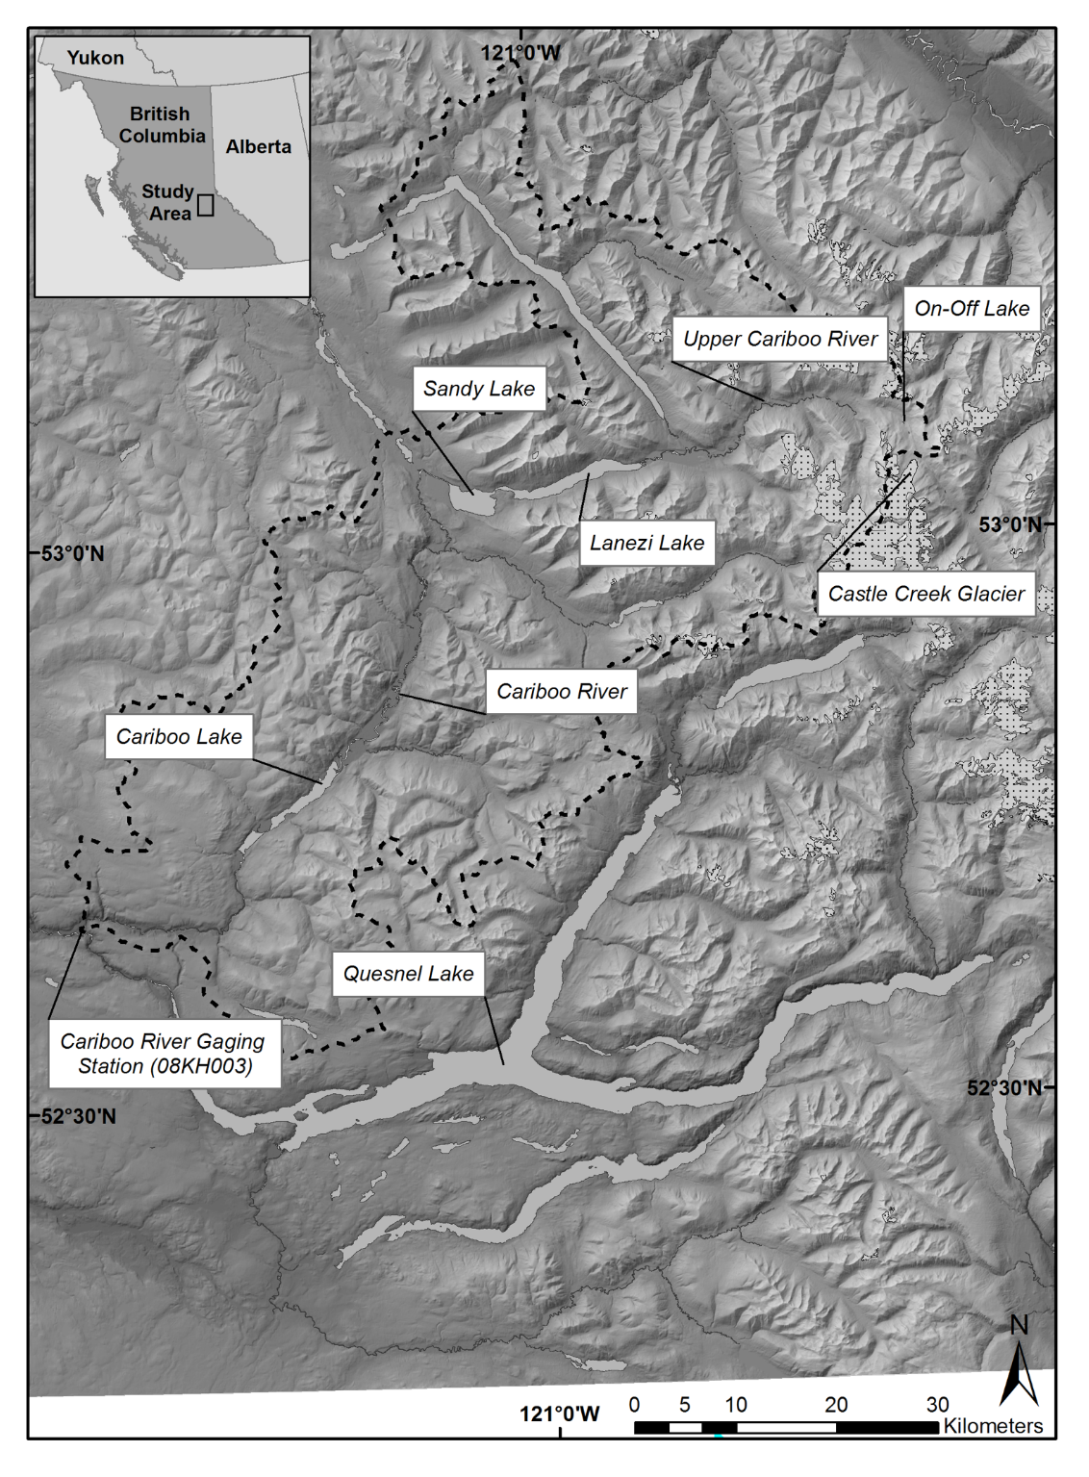

Figure 2.1: Map showing the Cariboo Lake basin.

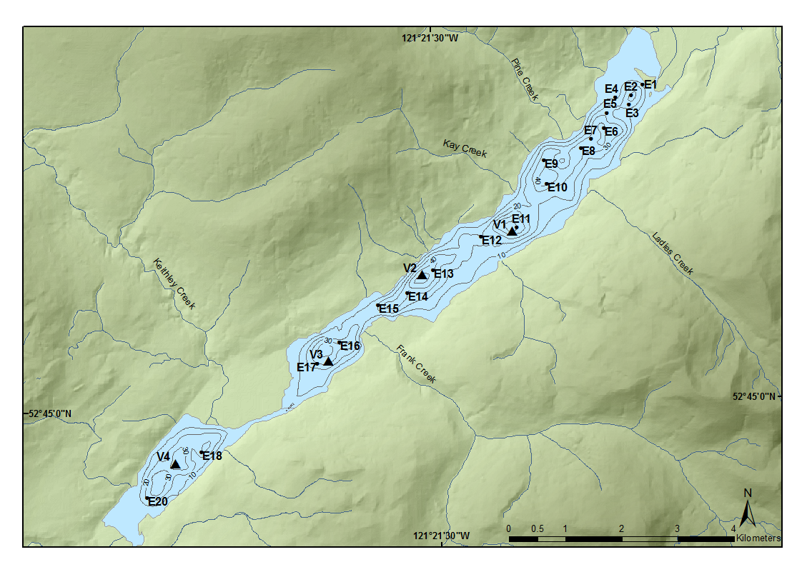

Figure 2.2: Map showing the Cariboo Lake bathymetry and coring locations.

Sediment connectivity to headwater glaciers along the Cariboo River is limited due to lake filtering by Lanezi and Sandy lake. Lanezi Lake is a deep fjord lake with a bathymetry reaching a maximum depth of 170 m. Sandy Lake is much shallower reaching a maximum depth of 6 m. The Matthews River, which meets the Cariboo River just below Lanezi Lake provides less filtered connection to meltwater from several alpine glaciers including the largest chunk of ice in the Cariboo Lake watershed, the Roberts Peak Galcier.

# 3 Methods

*Field Methods*

A field campaign was conducted during the summer of 2017 to collect sub-bottom acoustic soundings, dredge samples, and sediment cores. Thirty-four km of sub-bottom acoustic soundings were collected across Cariboo Lake using a 10 kHz StrataBox 3510 HD. An Ekman dredge was used to collect 20 ~10 cm3 samples of sediment from the lake bottom. The dredge samples were subsampled in the field using an 80 mm diameter PVC cylinder pushed into the block of sediment. The remaining sediment was kept as a bulk sediment sample. Four sediment cores (V1-V4) were collected using a Rossfelder submersible vibracorer with a 6 m long 70 mm diameter aluminum pipe. The Ekman subsample cores and the vibracores were split longitudinally with one half preserved as an archive and the other as a workging half. The working half samples were prepared for imaging by scraping the core parallel to the sediment laminae to create a flat surface which showed the sediment stratigraphy. The stratigraphy of cores V1 and V2 were best preserved and were selected for detailed analysis.

*Laboratory Methods*

Cores V1 and V2 were subsampled with 2 cm3 of sediment extracted at a 5 cm interval, with additional samples taken within stratigraphic breaks. The Ekman bulk samples and vibracores were analyzed for laminae thickness, organic content, and particle size. Laminae couplets were digitally counted and measured for thickness using the ImageJ @imageJcite software. Organic content was determined by loss-on-ignition analysis (550 °C) following methods in @Smith2003. Samples were first weighed to provide an initial wet weight, then dried at 60 °C and weighed again after oven drying. The samples were then placed in a furnace at 550 °C for 2.5 hours and weighed a third time. Grain size analysis was conducted using a Mastersizer Particle Size Analyzer 3000. Samples were prepared following methods by @Gray2010 to remove the fine fraction of particles from organic material. This involved a removal of organic material using three sequential alloquots of 20% H202 until the sample stopped reacting. To prevent flocculation of sediment grains the samples were dispersed in 0.05% solution of Calgon for 24 hours. The chronology of both cores was provided by AMS 14C dating of wood fragments at the André E. Lalonde AMS Laboratory at the University of Ottawa and varve chronology from laninae counting.

# 4 Results

## 4.1 Sub-bottom Acoustics

Acoustic stratigraphy from six selected transects conducted across Cariboo Lake reveal the range of morphologies and character of sedimentary deposits in Cariboo Lake (Fig. 4.1). Acoustic penetration is limited by coarser sediments proximal to river fan-deltas across Cariboo Lake (see Fig. 4.1 for fan-delta locations). Penetration, resolution and distinctive acoustic layering improves significantly along the thalweg of the lake bottom and in cross-lake transects more distal from the fan-deltas. Cross-hatching is observed over most of the acoustic record due to errant electrical interference from the research vessel. However, the interference does not affect the overall quality of the results in the six selected transects.

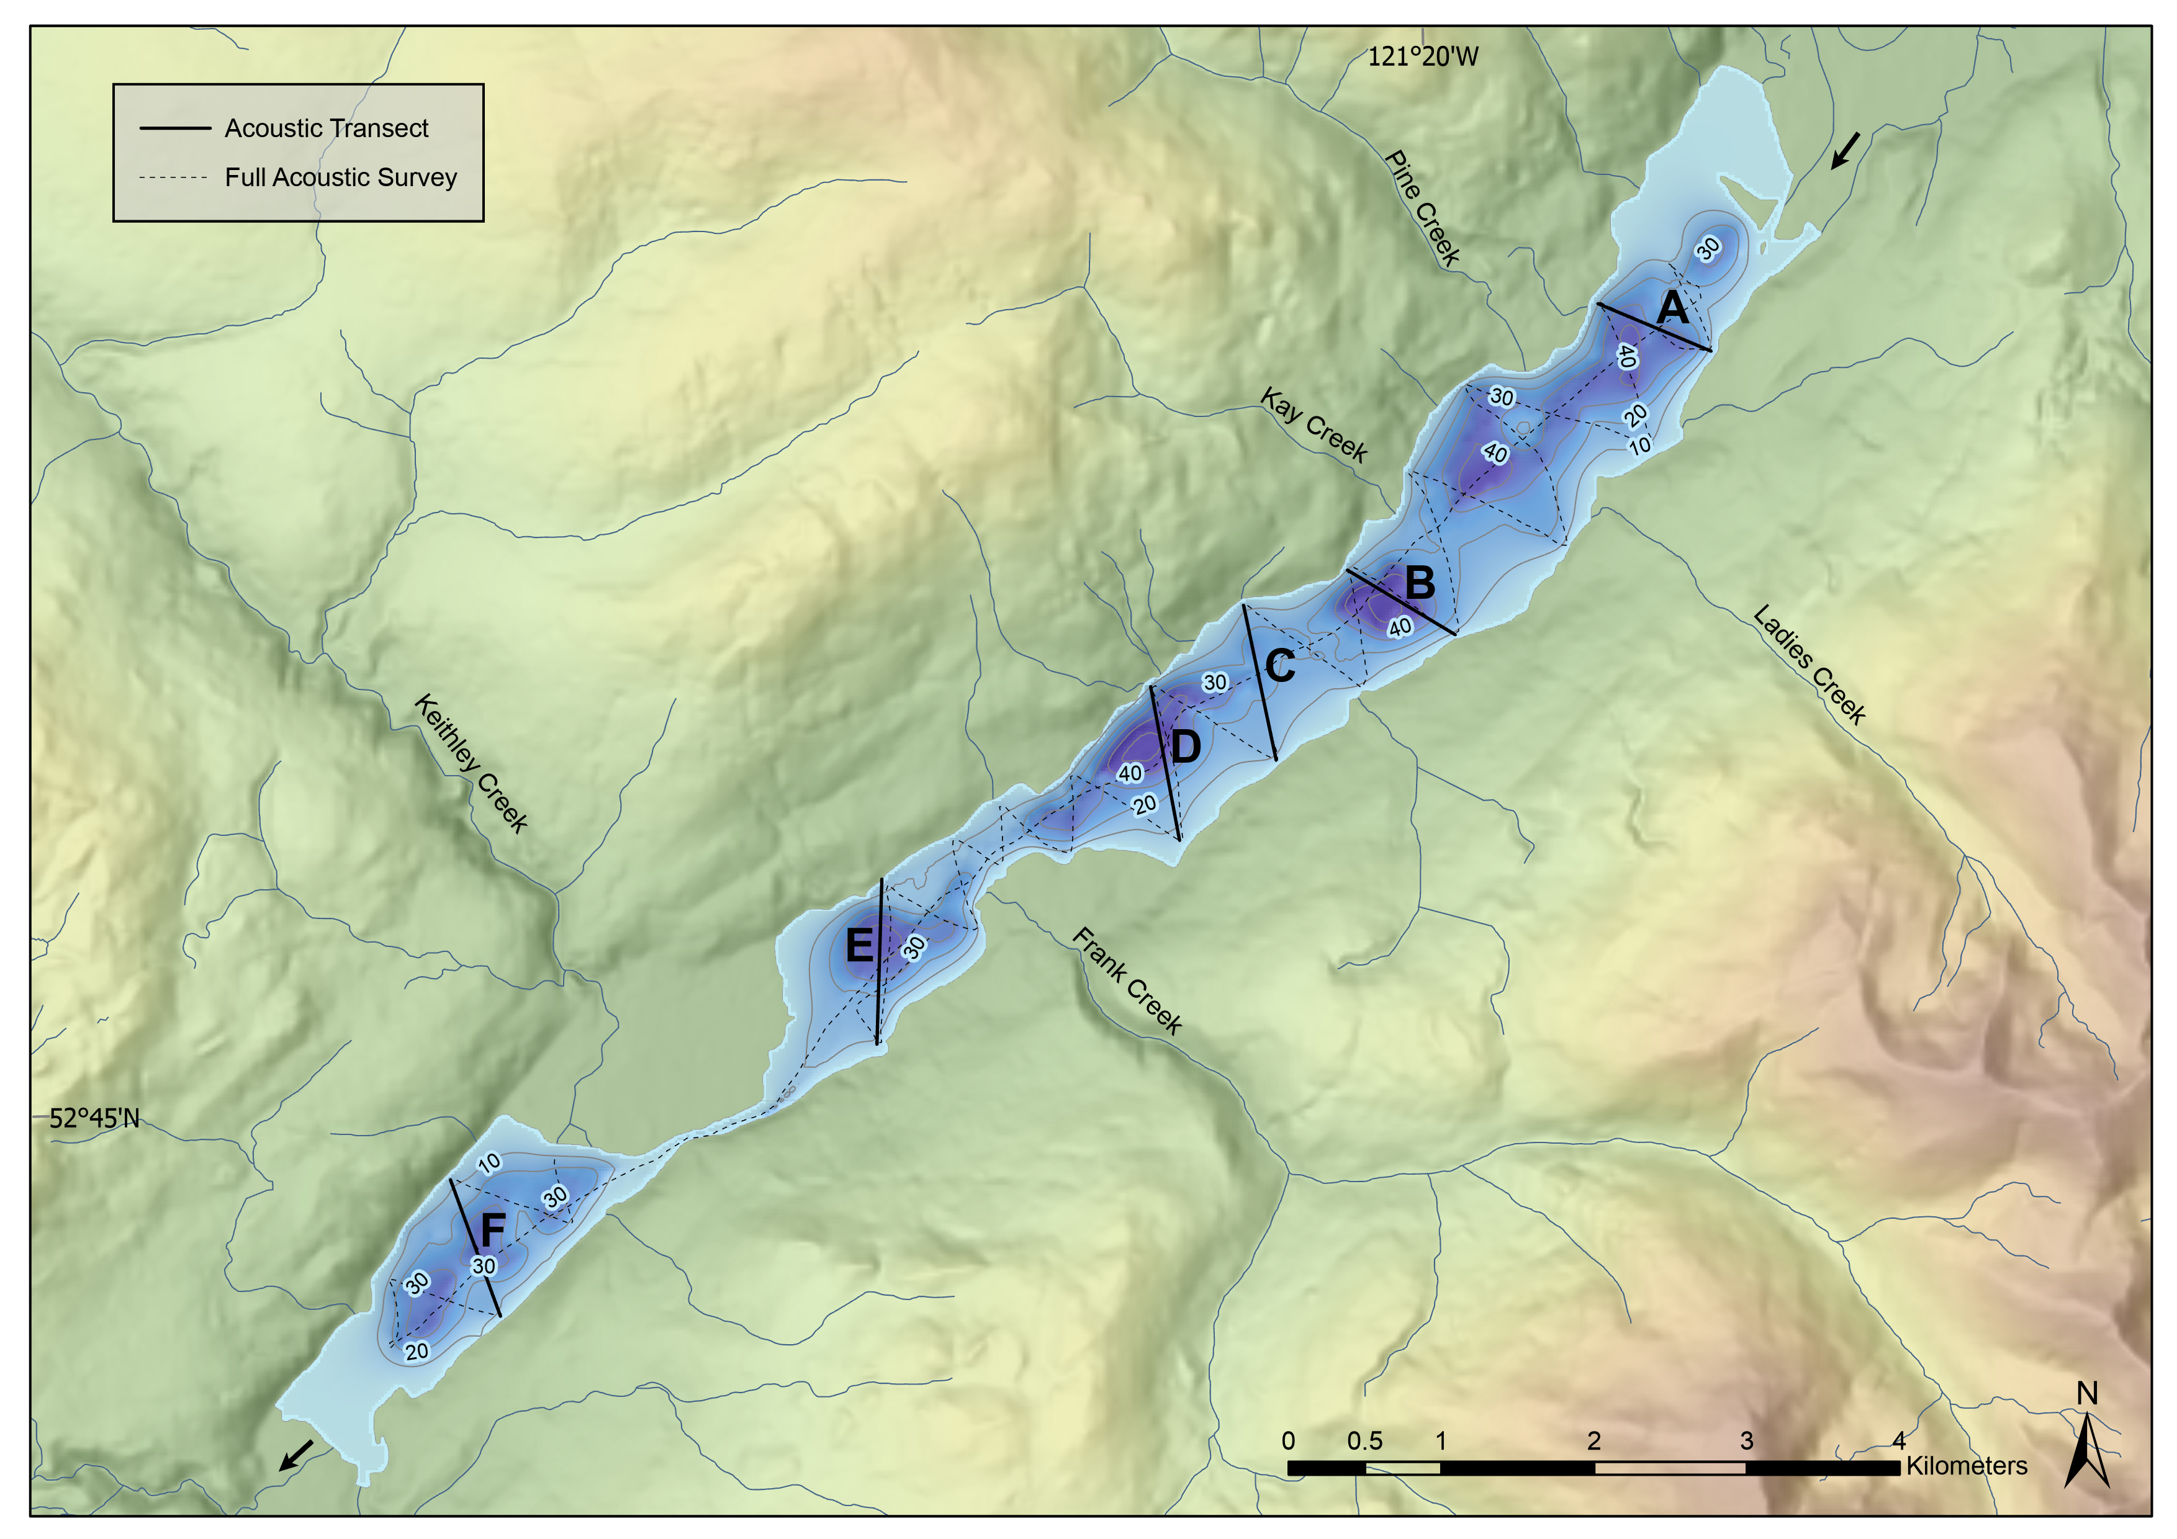

Figure 4.1: Map showing the Cariboo Lake bathymetry and Sub-bottom Acoustic Transects.

Transect A, one kilometer southwest of the headwater Cariboo River delta, has a strong acoustic reflector at the sediment-water interface indicating the presence of coarser-grained material on the lakebed (Fig. 4.2, A). Grab samples on this transect show a high fraction of sandy materials which act as an acoustic mask limiting the penetration of the acoustic signal to a depth of 1-2 m. An acoustic multiple (echo) is observed 45 m below the sediment surface caused by the limited penetration at the surface (Fig. 4.2, A - i).

Acoustically penetrable, well-layered sediment is observed 3.5 km from the Cariboo River delta in transect B (Fig. 4.2, B) proximal to core V1. Acoustic reflectors with 1-2 m spacing lies conformably over a hummocky basement which is observed on the south side of the transect (Fig. 4.2, B - i). The acoustic basement drops off below the observable record near the south channel-like depression. Well structured layering extends across the south side of the transect but pinches out towards the north shore (Fig. 4.2). On the south side of the transect, the thickness of the well structured layering ranges from 10 to 20 m. Underlying the layered sediments is a more massively layered facies which ranges from 12 to 25 m thick before the record is cut off.

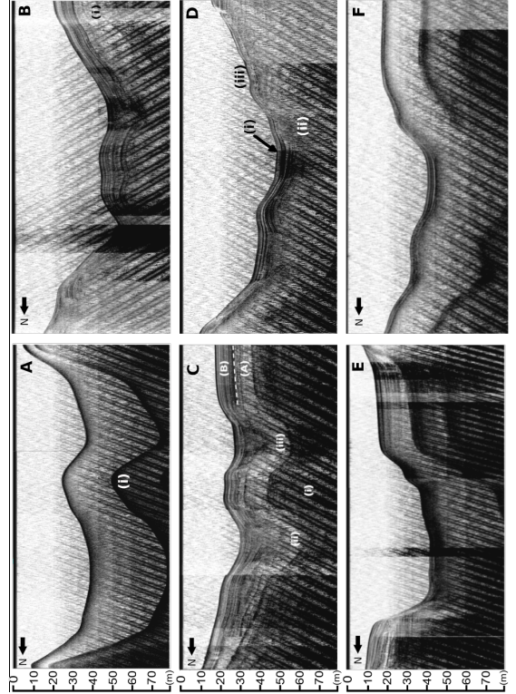

Figure 4.2: Panel of six selected sub-bottom acoustic transects A, B, C, D, E, and F. All transects are looking up-lake, see Fig. 2 for location. Transect A and B: Acoustic echo (multiple) is denoted by (i). Transect C: (i) denotes inferred bedrock or late-glacial material. (ii) and (iii) are v-notch scour channels. (A) and (B) are sediment facies. Transect D: Scour channels are denoted by (i) and (ii). Slumping is observed at (iii).

Acoustic penetration increases in locations about 4.5 km from the Cariboo River delta at transect C (Fig. 4.2, C). The acoustic record along this transect reaches a maximum sediment thickness of 35 m in two troughs - the maximum thickness of surficial sediments observed across Cariboo Lake in this study. The acoustic basement is considered to be either bedrock or coarse-grained glacial sediment from the Last Glacial Maximum (Fig. 4.2, C – i). Two sediment facies are observed across this transect based on geometry and the strength and continuity of reflectors. Some disruption of these facies is caused by slumping of side slopes (e.g. north end of transect C). The lower unit, facies A, has a thickness of ~ 12 m along undisturbed sections (Fig. 4.2, C - A) and is more massive to weakly acoustically layered. The contact with overlying sediment above facies A appears to be conformable at the south end and middle of the transect but unconformable in other places. The unconformities are most apparent in the two sharp crested v-notch channels at the middle of the transect. These channels are a continuation of those noted in transect B. These are inferred to be scour channels formed by erosive, higher energy, turbidity currents that probably date to deglaciation of the lake basin. The lack of numerous layers and generally lighter grey tone in facies A indicates a somewhat higher energy and more rapid deposition of coarser lacustrine sediment.

Facies B begins with high-amplitude parallel reflectors with 2-3 m spacing and conforms well with facies A below (Fig. 4.2, C). Facies B has a thickness of ~ 10 m along undisturbed sections and deepens to a maximum of 13 m within the scour channels (Fig. 4.2, C - ii & iii). The strength of reflectors in facies B are stronger and more numerous than those in facies A indicating more frequent events of lower overall magnitude during this time period. The strength of reflectors gradually decreases moving upwards and spacing thins to sub metre near the surface. The gradual decrease in reflectance is interrupted by a strong reflector at the top of facies B along the sediment-water interface.

The two buried troughs in transect C (Fig. 4.2, C - ii, iii) are significant and best expressed in this area of the lake. The north trough (ii) appears to be a depression that was continuously infilled by facies A and then B. Hence it most likely represents an older pre-existing feature. The sediments in the southern trough (iii) are interesting in that a wedge of sediment infill seems to be an unconformable deposit with both facies B below and facies A above. It is likely that an erosional channel developed after or in the later stages of facies A deposition which infilled the wedge. Sedimentation of the wedge was then truncated by the onset of the facies B sediment. While the two troughs might have been active at the same time during deglaciation, only the southern trough was reactivated at a later time and infilled with sediment prior to the onset of facies B deposition.

Transect D, to the northeast of the Frank Creek delta has well-layered sediments in the top 5-10 m and transitions to poor acoustic penetration below this (Fig. 4.2, D). The parallel reflectors observed in the uppermost sediment layers of transect D have a thickness of 2-3 m and have a higher amplitude compared to facies B in transect C. Some slumping of sidewall sediments is observed on the south sidewall (Fig 6, i).

Southwest of the Frank Creek fan-delta, acoustic reflectors along transect E show a decline in reflectance and a decrease in layer thickness to < 1 m. Acoustic masking from course grained sediment occurs at depths of 2-4 m along the south margin (Fig. 4.2, E). Total sediment thickness of finer, acoustically well-layered material along the north bench is significant approaching 10 m. The sedimentary environment southwest of the Frank Creek delta is comparably different to transects northeast of the delta. The profile suggests that much of the suspended sediment transported from the upper lake does not make it past the shallow lake depths (< 20 m) of the sill at the Frank Creek fan-delta apart from the northern most part of the transect. So, coarser sediment from the Frank Creek fan-delta dominates the south side of the transect and fine sediment deposition is restricted, or forced, to the north side. The Coriolis effect may enhance this as suspended sediments are deflected to the right as they enter Cariboo Lake from Frank Creek.

Similar to the Frank Creek fan-delta, the very shallow sill of less than 2 m opposite the Keithley Creek prograding fan-delta significantly reduces sediment connectivity to the main Cariboo Lake basin. (Fig. 1). Transect F, located close to the centre of the Keithley Creek sub-basin shows a maximum observable sediment thickness of 4 m concentrated in the basin thalweg (Fig. 8). Below this there is acoustic masking by coarser grained sediment. The acoustic reflectors within the top 4 m of transect F are acoustically penetrable, well layered and are conformable to the basin morphology. These reflectors are of higher amplitude compared to those in transect E and are thicker at 1-2 m. This suggests that significant amounts of coarse-grained sediments are found in this part of the lake, likely originating from the high energy Keithley Creek drainage basin. Fine faction sediments from the main Cariboo Lake are expected to make up a small percentage as transport into this sub-basin is limited by up-lake storage and filtering.

## 4.2 Spatial Trends in Surficial Sediment {spatial}

Twenty surficial sediment cores ranging from 6-12 cm thick were analyzed for grain size, laminae thickness, and organic content. These samples were collected following a longitudinal transect down Cariboo Lake and indicate how sediment flux varies with distance from the Cariboo River delta (Fig. 2.2, n = 20). Proximal to the Cariboo River delta (< 500 m) the structure of the surficial sediments exhibits massive layering, erosive contacts and the fraction of sand grains in these samples is greater than 60%. A sand bed with a thickness of 1 cm is observed in the bulk sample closest to the Cariboo River delta (Fig. 4.4, A). The D50 grain size follows a steep decline from 89.9 µm 300 m from the delta to 31.3 µm 550 m from the Cariboo River delta (Fig. 4.3). The decrease in grain size generally continues further down-lake besides samples retrieved near river deltas. A small increase in D50 is observed proximal to the Pine Creek delta from a low of 21.5 µm at 1.1 km, up to 28.2 µm 1.83 km from the main Cariboo River delta (Fig. 4.3). At distances greater than 2 km from the Cariboo River delta the fraction of silt grained sediments remains over 80 %, aside from core E16 which is near the Frank Creek delta. Proximal to the Frank Creek delta the D50 grain size nearly doubles in size from 7.92 µm at 6.4 km to 15.1 µm at 7.35 km from the Cariboo River delta. In main Cariboo River sub-basin, the most well-preserved core was taken 5.24 km from the Cariboo River delta in the deepest part of the sub-basin at a depth of 40 m and shows rhythmically laminated sediments (Fig @ref(fig:ekmanImgs, b). In the Keithley Creek basin the D50 grain size has an average of 15.9 µm (n = 3) and the composition of sediment 4.0% clay, 85.8% silt, and 10.2% sand (Fig. 4.3).

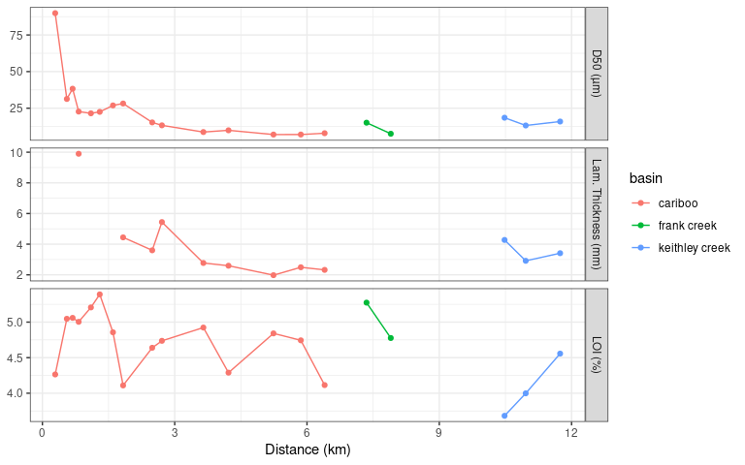

Figure 4.3: Sediment characteristics from the Ekman surficial bulk samples. Top panel is the D50 (µm) grain size, middle panel is the mean laminae thickness (mm), and the bottom pannel is LOI (%).

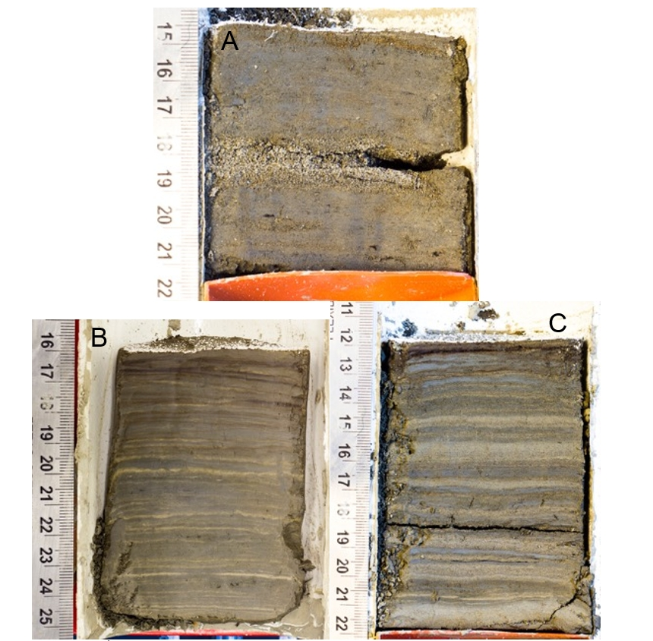

Figure 4.4: Selected surficial Ekman sediment core photographs. A (E1) is proximal to the Cariboo River delta. B (E13) was retrieved from the second deepest basin in the lake in the Cariboo River basin. C (E18) was retrieved from the Keithley Creek basin.

Sediment cores E9-E15 and E18-E20, retrieved from areas in Cariboo Lake that are distal from river deltas and have lake depths of 30-50 m, have a high fraction of silt and clay sediment and exhibit a sequence of fine-grained dark layers followed by coarse-grained light layers (Fig. 4.4, B & C). The thickness of sediment laminae within these surface cores demonstrate a gradual decreasing trend with distance down-lake from the Cariboo River delta (Fig. 4.3). Maximum varve thickness has an average of 4.7 mm (n = 6) in the Cariboo River basin and 7.9 mm (n = 3) in the Keithley Creek basin. In the Cariboo River basin, maximum varve thickness decreases by 0.62 mm/km and by 2.17 mm/km in the Keithley Creek basin with distance down-lake (Fig. 4.3). This decrease in laminae thickness with distance from the delta is attributed to the Cariboo River being the main source of sediment into Cariboo Lake as sediment flux typically declines with distance from the primary sediment source. The decline in thickness is steeper in the Keithley Creek Basin likely due to additional local inputs of coarser grained sediment coming from the Keithley Creek tributary which are not transported as far as suspended sediments.

Trends in percent organic content of surficial sediment cores where not found to exhibit systematic patterns with distance down-lake (Fig. 4.3). However, higher %LOI values were observed close to the main Cariboo River delta, likely due to the relatively low levels of erosion and high levels of allochthonous organic matter entering the lake. The lowest %LOI values were observed in the Keithley Creek basin which suggest higher levels of erosion in this basin.

The results from particle size, laminae thickness, and percent organics suggest that sediment delivered from the main Cariboo River is the primary source of sediment to Cariboo Lake. Massive layering of sediment and coarse-grained particle sizes are limited to areas proximal to Pine Creek, Frank Creek and Keithley Creek deltas where turbidity currents are active. Outside of these areas, where turbidity currents and bedload transport processes are reduced, the sediment in Cariboo Lake is largely comprised of rhythmically laminated silt and clay sediments likely transported primarily through suspended sediment currents from the main Cariboo River. In the Keithley Creek basin grain size and laminae structures are larger in size than those observed in the main Cariboo River basin suggesting sediment inputs from the Keithley Creek are significant (Fig. 4.4, C).

## 4.3 Temporal Sediment Record

Four glaciolacustrine sediment cores, which range from 2 – 4 m in length, were retrieved from the deepest basins of Cariboo Lake (Fig. 2.2). Cores V1 and V2 were selected for detailed analysis as these two cores had sufficient organic material for AMS radiocarbon dating, and their sedimentary record was well preserved. The chronology of the two cores is provided by AMS radiocarbon dating and varve counting. No evidence of volcanic tephra was found within either of the two cores. @Westgate1977 reports the most recent major volcanic ash event to reach central BC occurred 2100 yr BP, predating the basal age of the four sediment cores. This combined with the dark colour of the clastic core sediments prevented finding smaller volcanic ash events within the cores. Records of grain size, varve thickness, and organic content from these two cores demonstrate patterns in sediment delivery to Cariboo Lake over the past 2000 years.

*Chronology*

AMS radiocarbon dates obtained for cores V1 and V2 provide temporal control and evidence of sediment accumulation rates. A small twig from V1 at 347 cm yielded a date of 1899-1819 cal BP. Two separate samples were analyzed from V2, one comprised of a large twig at 222 cm yielding a date of 490-316 cal BP (V2a), and a combination of two separate organic pieces which were combined into one sample, a twig at 286 cm and a pine needle at 294 cm and provided a date of 2045-1895 cal BP (V2b). Figure 4.5, shows the dating calibration curves derived for the three AMS radiocarbon dates. The dates from samples V1 and V2b yield consistent accumulation rates of of 1.87 +/- 0.04 mm/yr and 1.47 +/- 0.11 mm/yr respectively. Sample V2a, yields an accumulation rate of 5.51 mm/yr, inconsistent with the rates provided for V1 and V2b.

Accumulation rates derived from Ekman surficial cores 13-15 are shown in Figure 4.6. These short cores are proximal to the V2 long core (see Figure 2.2), and exhibit accumulation rates of 2.24, 2.52, and 2.31 mm/yr respectively. Higher accumulation rates are expected for the Ekman samples are they are not subjected to the same level of compaction as the long cores. The consistency of the E13-15 accumulation rates compared with the V1 and V2b cores (Figure 4.6) suggests that the V2a is a suspect sample for temporal control. In viewing sample orientation and position along the outer core it is speculated that the sample may have been pulled down during the coring process due to the large twig size at about 4 cm. This probably results in an erroneously high accumulation rate for V2a. Accumulation rates in areas proximal to river inputs in nearby Quesnel Lake were measured to be as high as 0.72 mm/a (see Figure 9 in Gilbert and Desloges, 2012). While this is lower than Cariboo Lake, inputs are expected to be lower from this more arid and less glaciated portion of the Quesnel Lake watershed. Accumulation rates of 1.47 to 1.87 are consistent for a smaller and more glaciated Cariboo Lake watershed. Since the laminae thickness in Ekmans and vibra cores do not support the V2a accumulation rate of 5.51 mm/yr, it was not included in subsequent analysis. The AMS radiocarbon dates from samples V1 and V2b provide an important control when interpreting the inferred temporal pattern of sediment inputs to Cariboo Lake. The top section of cores V1 and V2 were disturbed - 110 mm for V1 and 70 mm at V2. While the Ekman cores were too short to overlap with the undisturbed sections of the vibra cores, laminae thickness similarities allow anchoring the top of core dates and 0/0 (depth/date) (Fig. 4.6).

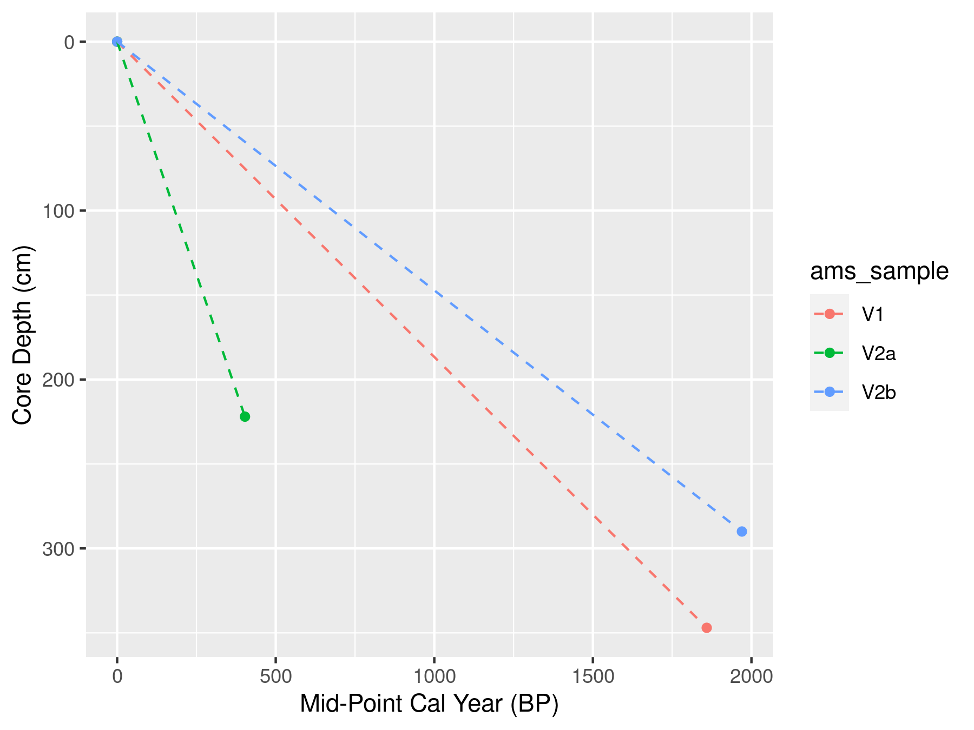

Figure 4.5: Sediment accumulation rates derived from the three C14 dates for Cores V1 (Red), and V2 (Green and Blue. The black line is the line of best fit through all three ams radio carbon dates.

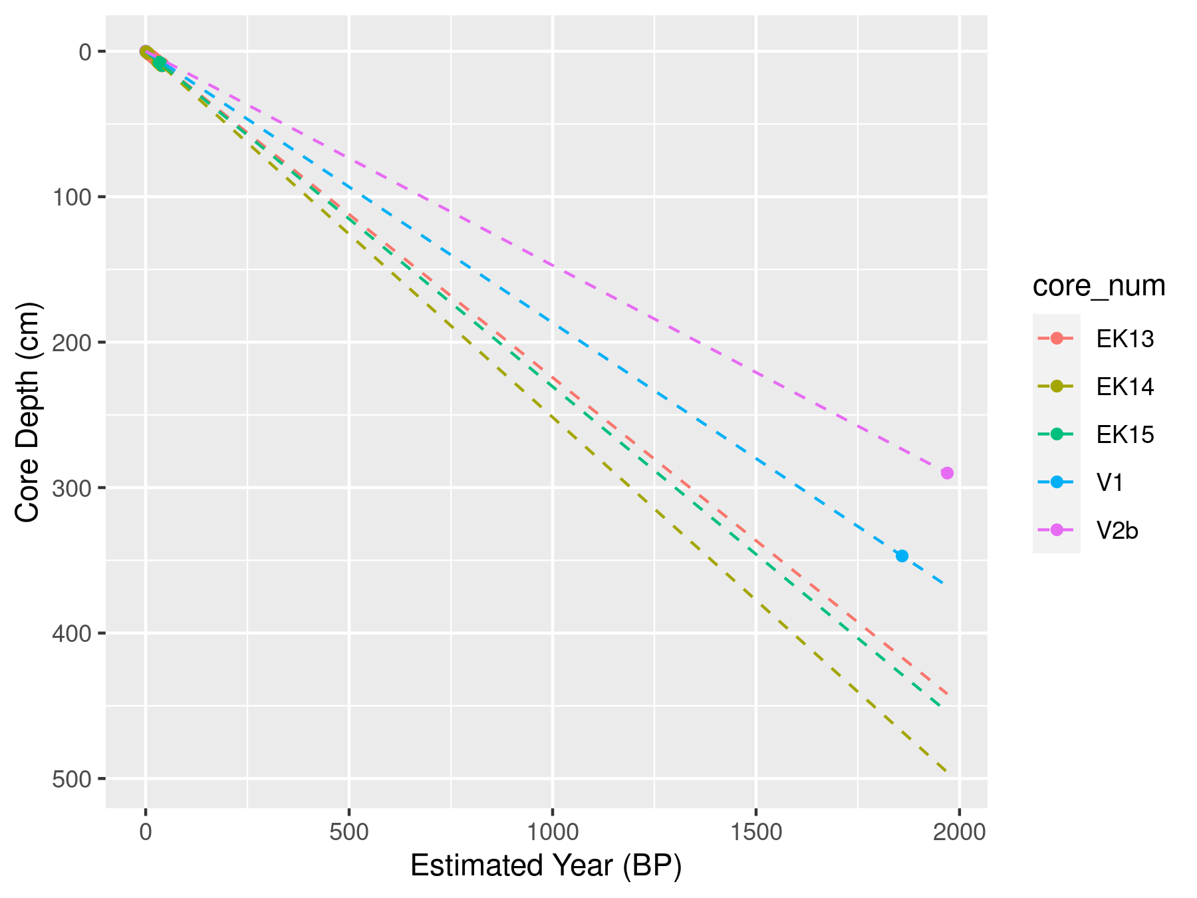

Figure 4.6: Cumulative accumulation rates for cores V1 and V2 and Ekman surficial cores EK13, 14, and 15 proximal to V2.

The sediment laminae chronology from cores V1 and V2 are interpreted as annual couplets or varves. This interpretation is supported by the AMS radiocarbon dated samples from cores V1 and V2 which corresponded reasonably well with the varve count chronology at the same depth. A difference between the two chronologies is present due to the presence of disturbed sections of core, core compaction, undercounting, and subjectivity in classifying thicker graded and massive laminae/beds that interpreted as flood events. In the absence of laminae couplets, the time elapsed over disturbed sections, was interpolated using a 30-year moving average sediment rate following methods described in Menounos et al., 2008.

Laminae couplets with thicknesses and grain size greater than 3 standard deviations from the mean were classified as event-based turbidite beds. These layers were observed to have defined beds and were well graded. Where possible the thickness, grain size statistics, and LOI were analyzed for each event layer. However, some layers did not have sufficient sediment to calculate both LOI and grain size. A more detailed description of the turbidite bed sediment characteristics is provided in the following section.

For core V1, laminae couplets were counted down to a core depth of 347 cm, where the AMS radiocarbon organic material was retrieved. This resulted in a couplet-derived age estimated of 1450 BP compared to the AMS radiocarbon estimate of 1899 - 1819 cal BP. For core V2 a date of 1886 BP was estimated by couplet couplet counting down to a core depth of 294 cm which matches closely with the V2b AMS radiocarbon date of 2045-1895 cal BP. The better alignment between the couplet counting age and the AMS derived age in V2 can be attributed to the higher degree of core disturbance in V1 compared to V2. Disturbed sections that had indiscernible couplets may have resulted in the undercounting within core V1. Still, based on the relatively close agreement between the AMS radiocarbon dated organic material and couplet counting, laminae couplets in V1 and V2 are considered to be deposited annually. Close alignment was not expected due to the aforementioned error present in the couplet counting methodology and the limited 14C dates available.

The basal age for each core is estimated using both the varve chronology and the AMS radiocarbon accumulation rate. The basal age of V1 at a depth of 382 cm is 1622 BP based on the varve chronology and 2046 cal BP, or about a 400 year difference from the extrapolated 14C date. The basal age of V2 at a depth of 291 cm is 1913 BP based on the varve chronology and 2007 cal BP by extrapolating the 14C. Accumulation rates estimated using varve chronology and AMS radiocarbon dates had a larger difference at V1 with 2.4 mm/yr and 1.87 +/- 0.04 mm/yr respectively. Closer agreement was observed at V2 with 1.52 mm/yr estimated by the varve chronology and 1.47 +/- 0.11 mm/yr from the AMS radiocarbon date. While V2 is likely the better predictor of changes in accumulation rates over the last 2000 years, both cores are considered below.

*Event-based Layers*

The turbidite bed grain size, LOI, and thickness shown in Table 4.1 illustrates the high sediment flux during these events compared to the non-event, annually occurring couplets. Increased grain size and varve thickness is observed for event-based layers and reduced LOI. Layer thickness is consistently higher for event-based layers compared to non-event couplets. Grain size and LOI do not show as strong of a response on average across all event-based layers apart from a single event observed at V2 with remarkably high grain size and low LOI around 400 CE (Figure 4.7). Since the primary delivery mechanism of sediment delivery to the core locations is through suspended sediment transport, the particle size physically possible to be transported during large sediment flux events is limited. Very few sand grains were observed in any section of either core, however event-based layers were comprised of almost exclusively silt grains compared to the non-event couplets which had a larger amount of clay. The composition of sediment grains within the event-based layers were all characterized by a single mode with less than 0.01% clay, over 98% silt and less than 1% sand. The grain size distribution for the non-event couplet sediments is characterized by a bi-modal distribution with an average composition of 16% clay, 83% silt, and 1%. The average D50 grain size of the event layers is 9.7 µm and 16.2 µm for V1 and V2 respectively and for couplet sediment is 7.6 µm and 6.4 µm for V1 and V2 respectively.

Figure 4.7, shows the timing of the event-based layers between V1 and V2. Four of the event layers at V1 and V2 coincide according to their layer thickness. Coincident measurements of grain size are provided for three of the seven event layers and no coincident measurements of LOI are provided between V1 and V2 due to the lack of sample material. The coincident layers observed around 750, 1250, 1600, and 1950 CE at both V1 and V2 are inferred to be from very large lake-wide events such as large slope failures upstream of both cores, unusually high flows during the spring freshet, or rain on snow events in the early fall delivering high sediment-yield across the lake leading to some coincident event layers at both cores. The temporally separated layers observed at ~250 CE at V1 and ~400 and ~1245 CE at V2 may be from isolated events such as from local hillslope failures, subaqueous side-wall slumps and/or very local tributary stream floods. Event-based layers, shown in Figure 4.7 were removed in subsequent trend analyses of varve thickness, grain size, and percent organics.

Table 4.1: Sediment characteristics of turbidite beds for V1 and V2. The “event_mean” is the mean sediment characteristic for the group, “event_sd” is the standard deviation for the group, and “event_n” is the number of layers analyzed in each group.

| core | metric | non_event_mean | event_mean | event_sd | event_n |
| --- | --- | --- | --- | --- | --- |
| V1 | D50 (µm) | 7.64 | 9.68 | 0.80 | 5 |
| V2 | D50 (µm) | 6.35 | 16.20 | 9.40 | 6 |
| V1 | LOI (%) | 4.75 | 4.67 | 0.53 | 3 |
| V2 | LOI (%) | 4.80 | 2.86 | 0.94 | 4 |
| V1 | Thickness (mm) | 2.40 | 10.32 | 4.24 | 5 |
| V2 | Thickness (mm) | 1.51 | 11.17 | 15.89 | 7 |

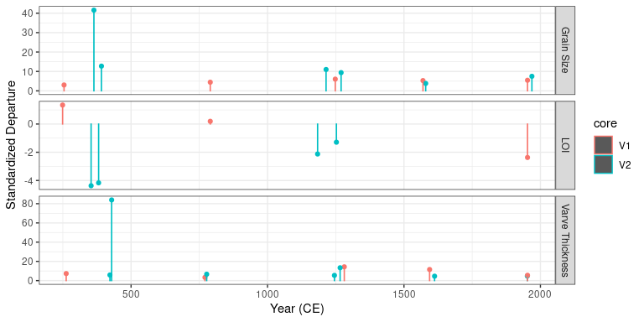

Figure 4.7: Timing and Standardized Departures of turbidite thickness, grain size, and LOI for V1 and V2. Year (CE) is the estimated year using linear interpolation from the AMS radiocarbon dates.

*Sediment Yield Statistics*

The mean varve thickness with event-based layers removed for V1 is 2.4 mm compared to V2 which is 1.5 mm. Higher varve thickness is expected at V1 due to its closer proximity to the Cariboo River delta. Figure 4.8 shows the time series of varve thickness measured from V1 and V2 and illustrates trends in suspended sediment delivery to Cariboo Lake. The measured couplet thicknesses in the two cores are plotted as standardized departures to facilitate comparison between the two cores. In each plot a 30-year moving average with a 1-year time step is plotted in black to emphasize decadal to centennial patterns in accumulation rate departures. Chronologies in Figure 4.8 assume a linear interpolation from the single AMS radiocarbon dates.

The 30-year average varve thickness remains above average from 0 to 750 CE, for both V1 and V2, with a stronger signal observed for V1 which is closer to the main Cariboo River outlet. Below average varve thickness is observed at both V1 and V2 from 750-1600 CE. After 1600 CE, trends in varve thickness between the two cores depart, with V2 above average during the Little Ice Age and V1 remains below average. Sub-centennial trends are not reported due to the coarse temporal control for both V1 and V2.

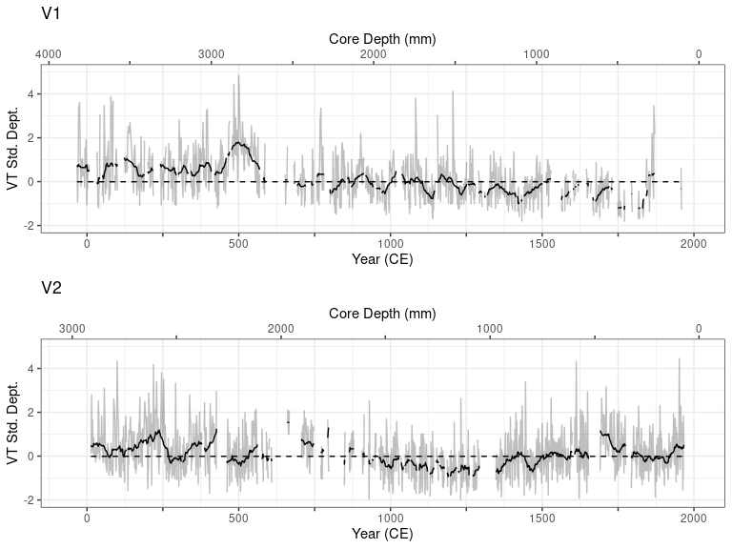

Figure 4.8: Standardized departure from the mean varve thickness for cores V1 and V2. The gray lines represent measured varve thickness at an annual resolution where available, the black line is a 30-year moving average, gaps correspond to portions of the core that did not have discernible varves. The bottom axes, labelelled Year (CE), was estimated using linear interpolation from the AMS radiocarbon dates.

*Grain Size*

The mean D50 grain size at V1 is 7.6 µm compared to 6.3 µm at V2. The higher grain size and varve thickness at V1 compared to V2 is consistent with the spatial trends in sediment delivery observed from the superficial short cores in Section ??. While based on a limited number of measurements compared to the varve thickness analysis, the temporal pattern in standardized departures of D50 grain size between the two cores shoes a consistent pattern (Figure 4.9). Both V1 and V2 have above average grain size between 0 to 700 CE and below average from 700 to 1500 CE. After 1500 CE, grain size follows an increasing trend with average to above average grain size. V1 shows a more dramatic increase in grain size compared to V2. Overall, grain size fluctuations at the coarse resolution of about 100-years shows good correspondence between the two cores over the last 2000 years.

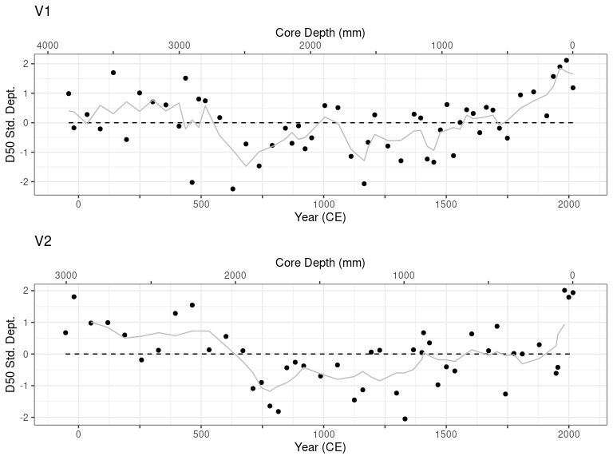

Figure 4.9: OPTION A - Standardized departure from the mean D50 grain size for cores V1 and V2. The black points represent D50 grain size at 5 - 10 cm intervals and the gray line is the 3 sample (~125 year) moving average. The top axes, labelelled Year (CE), are calculated as per Figure X. The black X’s on the bottom graph of V1 and V2 denote the AMS radiocarbon age (± dating error) and depth of the respective sample.

*Loss on Ignition*

The average LOI at V1 and V2 is similar at 4.76% and 4.80% respectively suggesting that the flux of allochthonous organic material to the core locations is not dependent on distance from the main Cariboo River as it is easily transported through the lake due to the low density. Figure 4.10 shows the percent mass lost on ignition (LOI) for both V1 and V2. Higher levels of organic content are shown in V1 and V2 from from 0-1000 CE and mostly below average from 1000-2000 CE. Specific periods of above average LOI for V1 occur around CE 0-500, 650-1100, 1150, 1300, 1750-1850 and below average between 50 BCE - 50 CE, CE 550-650, 1150-1300, 1350-1750, 1850-2000. LOI is above between at V2 around CE 0-100, 250-500, 650-900, 1800-1950, and below average between 1000-1050, 1300-1600, 1950-2000.

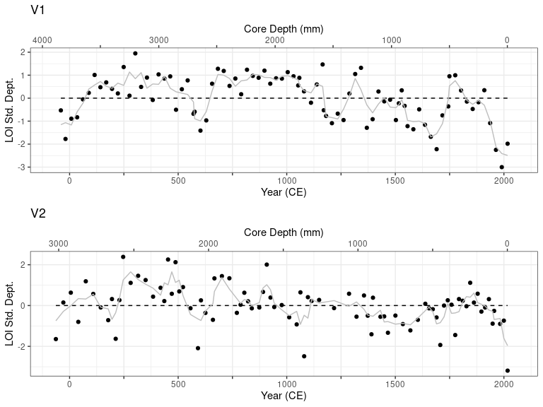

Figure 4.10: Standardized departure from the mean percent LOI for cores V1 and V2. The black points represent percent LOI at 2.5 - 5 cm intervals and the gray line is the 3 sample (~75 year) moving average. The top axes, labelelled Year (CE), are calculated as per Figure X. The black X’s on the bottom graph of V1 and V2 denote the AMS radiocarbon age (± dating error) and depth of the respective sample.

# 5 Discussion

Evidence of late Pleistocene deglaciation in the Cariboo Lake region is provided by coarse resolution sub-bottom acoustic records. More detailed late Holocene watershed activity is provided by more analysis at the centennial time-scale from sediment cores which span 2 ka BP. Previous evidence of lase Pleistocene deglaciation of the Cordilleran Ice Sheet has been provided by @Hodder2006 for Mud Lake to the west of the Rocky Mountain trench, who found the early phase of deglaciation starting prior to 9.6 ka BP. Research by @Menousnos2009 has pointed to the deglaciation of most of the Cordilleran ice sheet before 10.5 ka BP. Some evidence for late Pleistocene deglaciation is provided in the Cariboo Lake sediments. While the sediment accumulation rates are limited to the past 2 ka, we speculate on the transition of sediment facies observed in the longer acoustic records which extend into the late Pleistocene by assuming similar sediment accumulation rates during this time. While Holocene sediment accumulation rates in western Canada are known to be variable over the Holocene period, @Menounos2009 notes that early to mid Holocene rates were lower than late Holocene so there is perhaps a slight over estimation in sediment rate by extending back.

Sub-bottom acoustic records from Transect B shown in Figure 4.2, proximal to V1, indicate a transition from massive to well layered sediments occurring around 10.5 ka BP. This is based on a thickness of 20 m for the well layered facies and average C14 sediment accumulation rate of 1.9 mm/yr from core V1. Transect C, located in-between cores V1 and V2, has ~ 15 m of well layered sediment overlying a massively layered lower facies. This transition is estimated to have occurred around 9 ka BP based on an average sediment accumulation rate of 1.7 mm/yr for V1 and V2. The timing of this transition is similar to the onset of deglaciation and start of the Holocene sediment package within Mud Lake, BC in @Hodder2006 of 9.6 ka BP, Moose Lake, BC in @Desloges1999 around 10.3 ka BP, and the Upper Bow River, AB in @Leonard1999 11.7 ka BP. The sediment massively layered sediment package of Cariboo Lake that predates 10.5 - 9 ka BP is therefore likely a result high sediment delivery when ice was more proximal to the lake during the cool and wet climate. Following this, the transition to a more seasonally variable sediment flux, is expected as glaciers were depleted and retreated up the valley to Alpine Cirques by a warmer and drier climate around this time. It is expected sediment would have been primarily delivered during the late-spring freshet likely during the transition to a warmer climate where glaciers began declining in extent.

Although coarser grained sediments from discrete turbidite flows are found proximal to sidewall tributary deltas, silt and clay comprise over 90% of the sediment at V1 and V2 and is inferred to have been delivered via suspension from the main Cariboo River. Therefore, the sediment stratigraphy from cores V1 and V2 provide a high-resolution physical proxy for late Holocene hydroclimatic regimes in the watershed. The Cariboo River has two main tributaries, the Upper Cariboo River and the Matthew River which are connected to high alpine peaks and glaciers which provide a significant source of sediment. Sediment connectivity between these upper tributaries is limited however by several deep fjord like lakes including Lanezi and Sandy Lake along the Upper Cariboo River, and Ghost Lake along the Matthew River which act as sediment traps limiting the transfer of sediment from the production zones and results in the low sedimentation rates observed in cores V1 and V2. Although connectivity is limited, enough suspended sediment to produce annual varves reaches Cariboo Lake.

Across the Canadian Cordillera glacial lakes have a range of Holocene accumulation rates from relatively low at millimeters per year (e.g. Quesnel Lake with 0.7 mm/yr; @Gilbert2012), to centimeters per year (e.g., Lillooet Lake, 2-7 cm/a; @Gilbert2009), to a maximum of 0.5 m/a observers in Kluane Lake (@Gilbert2009). The relative range in accumulation rates has been understood to be a result in the variability of sediment production from glacier processes and steep topography [@Ballantyne2002], and the basin connectivity to deliver the sediment downvalley @cite. The average accumulation rate for Cariboo Lake of 1.7 mm/yr over the last two millenia, based off on an average of two radiocarbon dates, fits on the lower end of the range of accumulation rates previously identified across the Canadian Cordillera. While Quesnel Lake is adjacent to the Cariboo Lake Basin and located in a similar topographic setting the relatively low glacier coverage of 0.8% for the basin combined with the extremely deep lake depth which likely limits sediment deliver to the lake bed, and the large surface area contributes to the lower sediment accumulation rate observed compared in Quesnel to the rates observed in Carboo Lake. Moose Lake, which is fed by the steep valley glaciers of Mount Robson and has basin glacier coverage of 3.2%, has a average sediment accumulation of 2.7 mm/yr.

Previous authors on sediment varve studies have noted the sediment signal from climatic transitions typically occur over hundreds of years due to the slow reponse of sediment availability, conveyance, and deposition. Boundary conditions may also exist which can limit the sensitivity of sediment yield to climate change [@Desloges1999]

Higher organic content corresponds with higher rates of sediment accumulation from 0-700 CE.

Comparison to regional climate anomalies

* Thicker and coarser varves from 0-700 CE during colder wetter climate, why is there more LOI during this time.
* Smaller less coarse varves from 700-1500 CE during warmer dryer climate, LOI stays high.
* Coarser, thick varves during cold wet climate over the LIA, and LOI decreases
* Post- LIA LOI shows dramatic decline in organic content. Maybe lead lag effect? Boundry Conditions?

# 6 Conclusion

* Acoustic records provide coarse resolution of sedimentation into Cariboo Lake. Facies A and B from transect C, totaling 25 m thick provide evidence of sediment accumulation rates from 15 ka BP to present (based on 1.7 mm/yr avg accumulation rate from V1 and V2 AMS dates). Higher rates of sediment delivery to Cariboo Lake is evident over Facies A, from 15 - 9 ka BP. More frequent, but lower in magnitude reflectors are observed over Facies B, from 9 ka BP to present.
* Rhythmically laminated silt and clay sediment are found in deep sub-basins (30-50 m deep) distal from river deltas.
* Above average sediment accumulation to Cariboo Lake is observed from 0 to 700 CE, above average from 700-1500 CE based on grain size and varve thickness, and average to above average from 1500 CE to present.
* Past major climate anomolies do not correlate well across all sediment characteristics